www.MichiganTBirds.org

February, 2018 Volume 38 Issue 2

President’s Report
February 2018

Passing through cross sections of American scenes from the cornfields in Illinois to the golden sands and sunshine in Los Angles on Saturday January 20 Rick Thomas took us on a nostalgic journey across Route 66.
Come tour Pewabic Pottery, 10125 E. Jefferson, Detroit on Sunday February 18 at 1:00. Pewabic is a National Historic Landmark located in Detroit’s Jefferson Corridor. Pewabic artisans have handcrafted ceramic art beginning with raw, earthen materials and a clay mixer dating to the early 1900’s. A docent led tour will take us through their storied history beginning with the founding of Pewabic. (Tour $5.00 payable day of the event) Then join us for lunch at Sinbad’s Restaurant & Marina, 100 St. Clair, Detroit. Please RSVP to JoAnn Rodriguez by Wed Feb 14 at joannbill801@comcast.net or phone or text 248-719-0160.
Does your T-Bird have a story to tell? We would like to publish your story in the Monthly Newsletter. Write an article and submit it to Deb Jameyfield, Newsletter Editor debjohnson@accesstoledo.com
Don’t forget your 2018 yearly dues are due. A Membership Form is included in this Newsletter. Don’t get left out of 2018 events – mail your form and check today.

JoAnn Rodriguez
President

WWTC Board Members
P.O. Box 2597
Taylor, MI 48197

JoAnn Rodriguez, President
248-719-0160
Joannbill801@comcast.net

George Roscoe, Vice President
egroscoe@charter.net

Nancy Seyfarth, Secretary
nancylouseyfarth@gmail.com

Elaine Roscoe, Treasurer
eroscoe626@icloud.com

Jim & Marie Brucker, Membership
810-227-5379

m.brucker@comcast.net

Deb Jameyfield, Newsletter Editor
debjohnson@accesstoledo.com

Rick Carniga, Tech Advisor
rickcharniga@gmail.com

Dave Lau, Tech Advisor
toomanycars@charter.net

Advisor:
Larry Seyfarth 313-436-8327
Bob Smillie – 248-910-8031

New Members:

John Balch of Romeo, with his 1963 black convertible

Matthew Mihm, of Oxford, with his 1960 black hardtop

Diane and Jerome O’Brien of South Lyon, with their 1957 grey hardtop

Les Marinko of Taylor with his 1955 hardtop

Welcome back Bob Woody, of Monroe, who finished up his 1959 Flamingo Pink convertible.
we’re glad to see you back after all these years!

CLASSIFIED AD

Ad Rates
WWTC Members 3 months free
Non-members 2 months $5.00

AUTOMOTIVE TOOLS FOR SALE:
1:24 Scale Cars by Danbury Mint.
Excellent condition in their original packaging with documentation.
1956 White Thunderbird Convertible with removable top and spare tire
1961 Turquoise Thunderbird Metallic Convertible with removable top
$75.00 each or both for $130.00
1:18 Scale - 1955 Yellow Thunderbird Convertible $20.00

3 ½ ton Craftsman floor jack $70.00
3 ½ ton each Craftsman jack stands $15.00 a pair
1 pair of car ramps 12000 GVW each $35.00 pair
Package deal: all 3 items $100.00
If interested please contact Wally Wigand @ 313-802-7000

1964 T-BIRD CONVERTIBLE FOR SALE:
Original, Excellent Condition. Color Red
Asking $20,000
Call Dennis Hermatz (734)748-6259

BRAND NEW COVER FOR 1964-66 T-BIRD:
Asking $200 or best offer.
Also have a pair of used rear tail light lenses for 64 T bird asking $75 for both.
Call Ken at (734)536-3715

Fun at the Route 66 Program
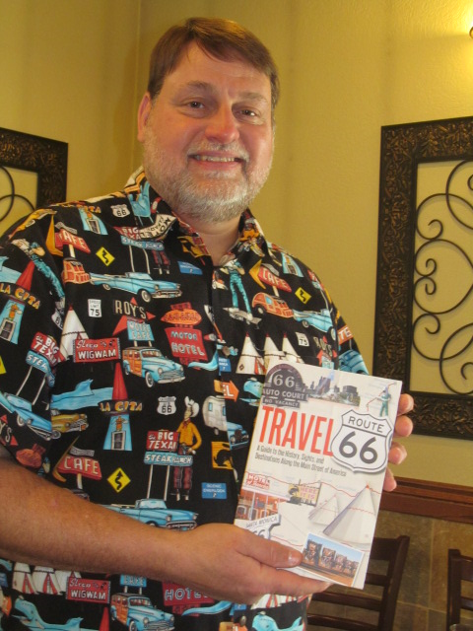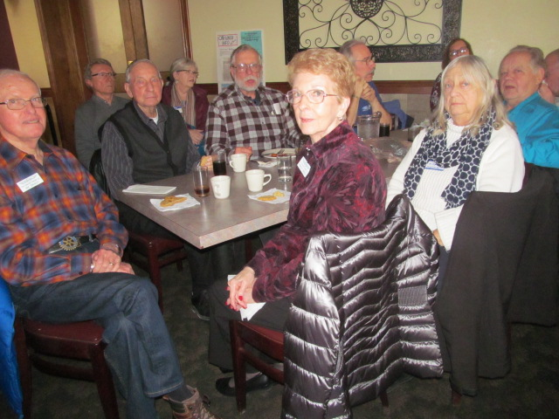
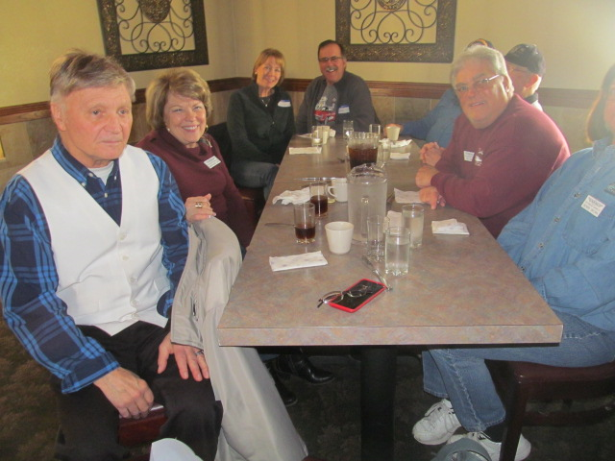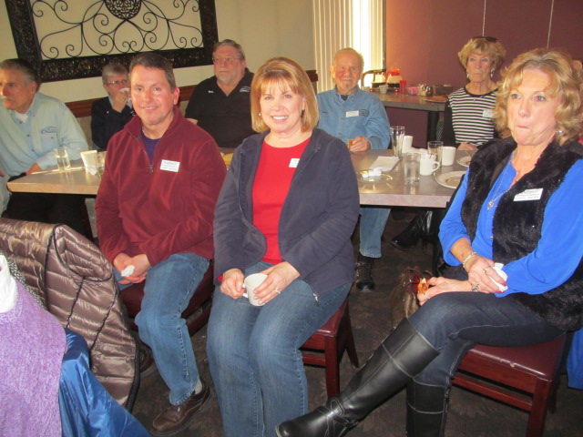
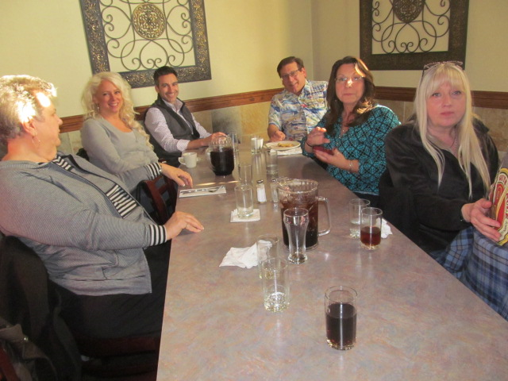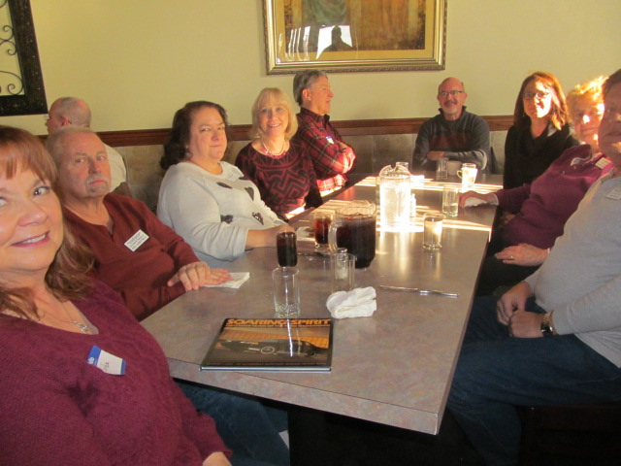
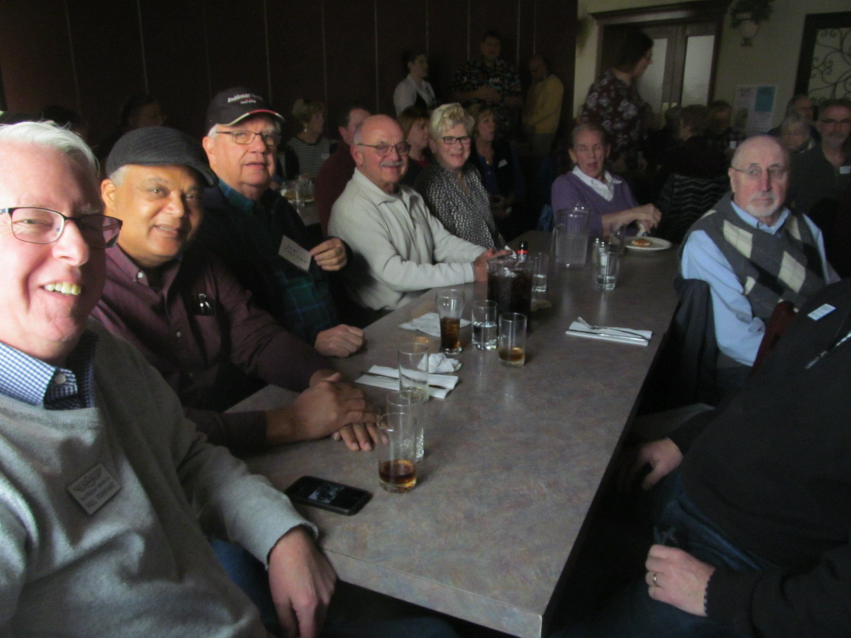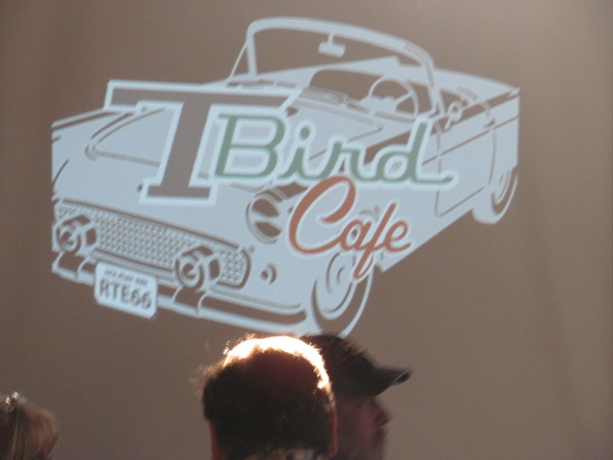

2018 Schedule of Events

Jan 20 (Sat) – Presentation by Rick Thomas – Iconic Route 66, Pizza
Buffet 1:00 - Angelo Brothers, 33550 Ford Rd., Westland
Feb 18 (Sun) – Pewabic Pottery Tour and Lunch at Sinbads
March 24 (Sat) - Motor City Solutions Tour
April – Eleanor & Edsel Ford House Date and lunch to be determined
May 19 (Sat) – Tour Piquette Plant – Lunch to be determined
June – Gilmore Museum Tour To be determined
June 16-17 – Motor Muster (nonsanctioned)
July 22 (Sun) – Annual Picnic
Aug 12 (Sun) – Pre-Dream Cruise
Aug 26 (Sun) – Hines Park Cruise
Sept 16 (Sun) – All T-Bird Day
Oct 21 (Sun) – Hines Park Cider Cruise
Nov 3 or 10 – 2019 Planning Meeting
Dec 2 (Sun) – Annual Christmas Party

Water Wonderland Thunderbird Club
P. O. Box 2597
Taylor, MI 48180

MEMBERSHIP FORM
New Member | Renewal
Name
WWTC is a non-profit organization dedicated to the preservation, restoration and enjoyment of all Thunderbirds.
Spouse
Address
City
State/Province

Zip/Postal

Member’s Birth Date

month/day)
(

Spouse/partner
’s ____________________

Email

Address

Home

Phone

Cell

Phone

TBird

Style

Color

TBird

Style

Color

NEW: If you are a member of other Thunderbird Clubs, please provide us with those membership numbers:
VTCI (Vintage Thunderbird Club Interntl) #________ ITC (Interntl Thunderbird Club) #________
CTCI (Classic Thunderbird Club Interntl) #________ Other: name __________________, # ________

PLEASE MAIL CHECK OR MONEY ORDER PAYABLE TO WWTC TO:
Water Wonderland Thunderbird Club
P.O. Box 2597 Email Newsletter $25/member/year
Taylor, MI 48180 Mailed Newsletter $35/member/year

WWTC was established in 1981 as a non-profit Michigan organization. We are also a local chapter of the Vintage Thunderbird Club International (VTCI) as well as a current chapter in International Thunderbird Club (ITC). WWTC is dedicated to the preservation, restoration and enjoyment of all Thunderbird automobiles. Our members are from all walks of life sharing one common interest: the love of Thunderbirds.

We publish a monthly newsletter full of interesting articles, technical tips, events and want ads for T-Bird enthusiasts. We meet on a monthly basis for a variety of social events and encourage participation by driving our Thunderbirds to the event - although you do not have to own a running Thunderbird to be a member.

We welcome ALL years of T-Birds! Why not come join us? For more information, visit us at www.MichiganTbirds.org, or contact Membership Director Marie Brucker (email: m.brucker@comcast.net, phone 810-227-5379). We hope to see you soon!

FOR OFFICE USE:

Check

No.

Check

Amount

Check

Date

